2022 BCCE Fun Run Details

Time: Monday, August 1, 2022 Arrive by 5:50 am – Run start 6:00 am

Place: Meet between Hillenbrand Hall and the McCutcheon Parking garage – see map.

Timing: The run will not be timed – feel free to time yourself! We are looking forward to running together as a fun way to start the week!

Distance: 3.06 miles

Aid: There will not be any water along the course. Feel free to bring your own. There will be water and snacks at the finish line. It should not be too hot in the morning, but watch the weather.

Course: The course will not be closed to traffic so please obey traffic signals and be alert at street crossings. It will be marked and we anticipate having volunteers at corners to help guide you. The course is very flat and all on pavement/sidewalks. See map below.

Finish: The course is a loop and we will finish back where we started, very close to the dorms for those staying on campus. There will be water, snacks, and a commemorative gift!

The Route:
- Assemble at sidewalk area between Hillenbrand Hall and the McCutcheon Parking Garage by 5:50 AM for a 6:00 AM start. Faster runners to the front, slower runners to the back.
- Go straight, then right then left to run around McCutcheon Hall, then turn left on to State Street.
- You’ll run more than 1 mile, when you are at the corner of West State Street and North Grant Street turn left. This is the State and Grant Street Gateway arch.
- At the end of the Purdue Memorial Union Club Hotel, turn left. You’ll run past Grissom Hall named for Purdue Astronaut and graduate Gus Grissom, Heavilon Hall, and Wetherill Hall.
- At the end of Wetherill Hall turn right. Run through Centennial Mall past the Sinninger Pond, the Purdue Bell Tower, and the WALC. Run past the Engineering Fountain then on the Gateway Arch by Neil Armstrong Hall of Engineering. Neil Armstrong’s statue is to the right.
- Veer a bit left after you run under the Gateway to the Future Arch and proceed down West Stadium Street.
- Turn left on Martin Jischke drive to run past Rankin Track and Field Complex and the Purdue Co-Rec.
- At Third street turn right, run past Hillenbrand Hall, around the McCutcheon parking garage, then back to the starting location!
- Get a water, snack, and your gift!

Notable landmarks you are running past (or close to!)

- Loeb Fountain
- State Street and Grant Street Gateway to Purdue
- Block-P statue
- Lion’s Head Fountain
- Purdue Bell Tower and Sinninger pond
- Engineering Fountain
- Neil Armstrong Statue (He has a slide rule!)
- Gateway to the Future Arch
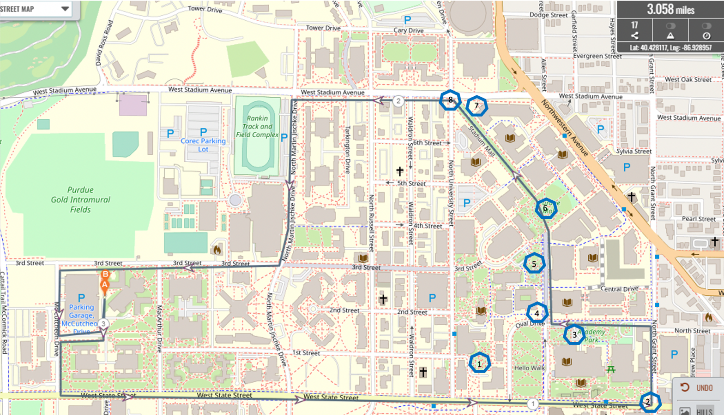

Purdue Fun Run Map and landmarks. The race begins at point A, and ends at point B.

